ST ANTHONY OF PADUA PARISH

Celebration of life
Funeral Planning

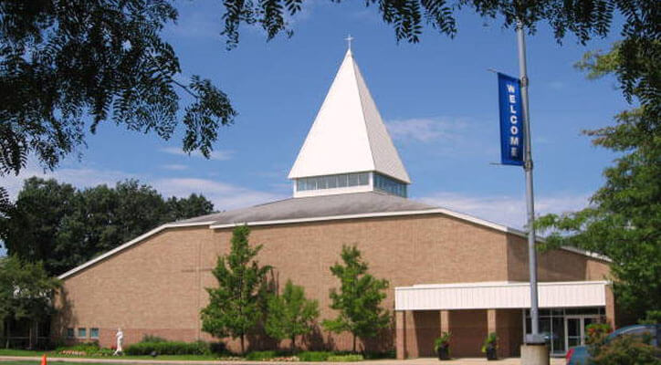

2510 Richmond St. NW Grand Rapids MI 49504
Phone: (616) 453-8229 Fax: (616) 453-8053
www.saparish.com
Point of ponder
Who
Family
Friends
Priest or Deacon
Military Honor Guard
What
Casket/Cremation
Visitation
Vigil (with or without open sharing)
- Scripture Service
- Rosary
- Combination of Scripture and Rosary
Mass / Funeral Service
- Readings
- Music
- reflection – written (3-5 minutes) eulogy, song, poem
Luncheon – How many
Grave Service – Grave site or Chapel
Where
Funeral Home
Church
Cemetery
Why
Celebrate Life with us and now with God
How
Meet with Funeral home
Meet with Priest or Deacon

INTERCESSIONS FOR FUNERALS
The response to the Prayers is: “Lord, hear our prayer”.
- For ______________, who in baptism was given the pledge of eternal life, that (he/she) may now be admitted to the company of the saints.
We pray to the Lord R./ “Lord, hear our prayer”.

- For our (brother/sister) who ate the body of Christ, the bread of life, that he/she may be raised up on the last day.
We pray to the Lord R./ “Lord, hear our prayer”.

- For our deceased relatives and friends and for all who have helped us, that they may have the reward of their goodness.
We pray to the Lord R./ “Lord, hear our prayer”.

- For those who have fallen asleep in the hope of rising again, that they may see God face to face.
We pray to the Lord R./ “Lord, hear our prayer”.

- For the family and friends of our (brother/sister) _______________, that they may be consoled in their grief by the Lord, who wept at the death of his friend Lazarus.
We pray to the Lord R./ “Lord, hear our prayer”.

- For all of us assembled here to worship in faith, that we may be gathered together again in God’s kingdom.
We pray to the Lord R./ “Lord, hear our prayer”.
Funeral Readings Suggestions
First Readings
Ecclesiastics 3:1-8,14 Seasons
Proverbs 21:25 Mother / Wife
Wisdom 3:1-9 Hand of God
Sirach 3:2-7, 12-14 Father
Sirach 6:14-17 Friend
Wisdom 4:7-14 Shall be at rest
Isaiah 57:1-2 Just man

Second Reading
2 Timothy 4:6-8 Kept the faith
Romans 6:3-4, 8-9 Baptism into death
1 Thessalonians 4:13 Fallen asleep
Revelation 14:13 Die in the Lord
2 Corinthians 5:1, 6-10 Courageous
2 Thessalonians 2:16-17 Encourage
2 Corinthians 4:16-18 Do not lose heart
2 Corinthians 4:14 – 5:1 Transition
2 Corinthians 12:31- 13:8 Love

Suggested Music for Funerals
Amazing Grace | Song of Farewell
Be Not Afraid | Come to His (Her) Aid
Behold the Lamb | Go Forth
Carry Me Home | Go Silent Friend (Tune of Danny Boy)
Come to Me | In Every Age
Eye Has Not Seen | May the Angel Lead You Into Paradise
Fly Like A Bird
Go In Peace | Psalms
Hail Mary - Gentle Woman | Shepherd Me O God
Here I Am Lord | The Hand of God Shall Hold You
Hosea | The Lord Is Kind and Merciful
How Can I Keep From Singing | The Lord Is My Light
How Great Thou Art | The Lord Is My Shepherd
I Am the Bread of Life | To You O Lord, I Lift Up My Soul
I Can Only Imagine
I Danced In the Morning
I Have Loved You
I Will Be With You
Let There Be Peace on Earth
Miracle of Grace
On Eagles Wings
Pastures of the Lord | Taste and See
Prayer of St. Francis | We Remember
Shall We Gather at the River | You Are Near
Shelter Me O God
Sing A New Song
Sing With All the Saints

GENERAL INFORMATION

Name of Deceased__________________________ Age _____
Residence:__________________________________________
Next of kin ______________________Relationship _________
Address _________________________ Phone _____________
Date of Death ______________ Cause of Death ____________
Anointing of Sick ___________Priest ____________________
Funeral Home _____________________Phone _____________
Viewing Time _______________________________________
Vigil Service __________________Scripture/Rosary ________
(Date and time) (Minister)
Viewing in Narthex before Funeral Mass? Yes/No Time ________
Funeral Mass / Service _________________________________
(Day Date Time )
Presider ____________________________________________
Place of burial (cemetery)_______________________________
Grave side service: Yes / No Committal at Church: Yes / No
Luncheon (Time and estimated number) ___________________
Special Requests:

